**LAB PROGRAM 2 (BANK DATABASE) Name : Tarun Sri Ram**

**USN:1BM19CS171**

**Queries:**

|  |
| --- |
| create database bank; |
|  | use bank; |
|  |  |
|  | create table branch ( |
|  | branch_name varchar(25), |
|  | branch_city varchar(15), |
|  | assets int, |
|  | primary key (branch_name) |
|  | ); |
|  |  |
|  | create table bank_account ( |
|  | accno int, |
|  | branch_name varchar(25), |
|  | balance int, |
|  | primary key (accno), |
|  | foreign key (branch_name) references branch(branch_name) |
|  | ); |
|  |  |
|  | create table bank_customer ( |
|  | customer_name varchar(10), |
|  | customer_street varchar(25), |
|  | customer_city varchar(15), |
|  | primary key (customer_name) |
|  | ); |
|  |  |
|  | create table depositer ( |
|  | customer_name varchar(10), |
|  | accno int, |
|  | primary key(customer_name, accno), |
|  | foreign key (customer_name) references bank_customer(customer_name), |
|  | foreign key (accno) references bank_account(accno) |
|  | ); |
|  |  |
|  | create table loan ( |
|  | loan_number int, |
|  | branch_name varchar(25), |
|  | amount int, |
|  | primary key (loan_number), |
|  | foreign key (branch_name) references branch(branch_name) |
|  | ); |
|  |  |
|  | insert into branch values('SBI_Chamrajpet', 'Bangalore', 50000); |
|  | insert into branch values('SBI_ResidencyRoad', 'Bangalore', 10000); |
|  | insert into branch values('SBI_ShivajiRoad', 'Bombay', 20000); |
|  | insert into branch values('SBI_ParliamentRoad', 'Delhi', 10000); |
|  | insert into branch values('SBI_Jantarmantar', 'Delhi', 20000); |
|  | commit; |
|  |  |
|  | insert into bank_account values(1, 'SBI_Chamrajpet', 2000); |
|  | insert into bank_account values(2, 'SBI_ResidencyRoad', 5000); |
|  | insert into bank_account values(3, 'SBI_ShivajiRoad', 6000); |
|  | insert into bank_account values(4, 'SBI_ParliamentRoad', 9000); |
|  | insert into bank_account values(5, 'SBI_Jantarmantar', 8000); |
|  | insert into bank_account values(6, 'SBI_ShivajiRoad', 4000); |
|  | insert into bank_account values(8, 'SBI_ResidencyRoad', 4000); |
|  | insert into bank_account values(9, 'SBI_ParliamentRoad', 3000); |
|  | insert into bank_account values(10, 'SBI_ResidencyRoad', 5000); |
|  | insert into bank_account values(11, 'SBI_Jantarmantar', 2000); |
|  | commit; |
|  |  |
|  | insert into bank_customer values ('Avinash', 'Bull_Temple_Road', 'Bangalore'); |
|  | insert into bank_customer values ('Dinesh', 'Bannergatta_Road', 'Bangalore'); |
|  | insert into bank_customer values ('Mohan', 'National_College_Road', 'Bangalore'); |
|  | insert into bank_customer values ('Nikhil', 'Akbar_Road', 'Delhi'); |
|  | insert into bank_customer values ('Ravi', 'Prithviraj_Road', 'Delhi'); |
|  | commit; |
|  |  |
|  | insert into depositer values('Avinash', 1); |
|  | insert into depositer values('Dinesh', 2); |
|  | insert into depositer values('Nikhil', 4); |
|  | insert into depositer values('Ravi', 5); |
|  | insert into depositer values('Avinash', 8); |
|  | insert into depositer values('Nikhil', 9); |
|  | insert into depositer values('Dinesh', 10); |
|  | insert into depositer values('Nikhil', 11); |
|  | commit; |
|  |  |
|  | insert into loan values(1, 'SBI_Chamrajpet', 1000); |
|  | insert into loan values(2, 'SBI_ResidencyRoad', 2000); |
|  | insert into loan values(3, 'SBI_ShivajiRoad', 3000); |
|  | insert into loan values(4, 'SBI_ParliamentRoad', 4000); |
|  | insert into loan values(5, 'SBI_Jantarmantar', 5000); |
|  | commit; |
|  |  |
|  |
|  |
|  |
|  |
|  |
|  |

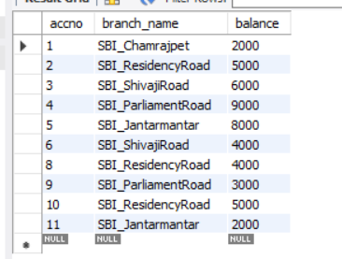

Bank Account Table

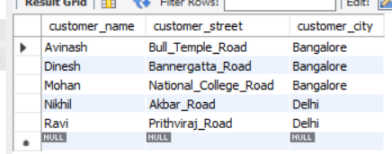

Bank Customer Table

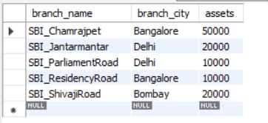

Branch Table

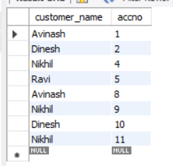

Depositor Table

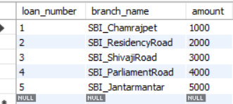

Loan Table

**Query 3 :**

use bank;

select distinct c.customer_name

from bank_customer c,bank_account b

where exists(select d.customer_name,count(d.customer_name)

from depositer d,bank_account ba

where ba.accno = d.accno and

c.customer_name = d.customer_name and ba.branch_name = 'SBI_ResidencyRoad'

group by d.customer_name having count(d.customer_name)>=2);

**Output:**

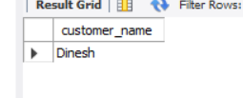

**Query 4:**

use bank;

select d.customer_name from depositer d,branch b,bank_account a

where b.branch_name=a.branch_name

AND a.accno=d.accno

and branch_city='Delhi'

group by d.customer_name

HAVING COUNT(distinct b.branch_name)=(

SELECT COUNT(branch_name)

FROM branch

WHERE branch_city='Delhi');

**Output:**

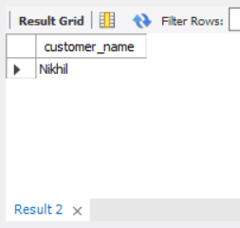

**Query 5:**

delete from bank_account

where branch_name in

(select branch_name from branch where branch_city = 'Bombay');

select * from bank_account;

**Output:**

